Rev. Hanna Peterson Shearer Installation
April 30, 2017
Kennewick First Presbyterian Church
Prelude

Processional “Come Thou Fount” Screen
Welcome and Call to Worship Psalm 146 Elder Corey Schlosser-Hall

Leader: Praise the Lord, O my Soul! We will praise the Lord all our lives.
We will sing praise to our God as long as we live.
People: Blessed are they whose hope is in the Lord.
Leader: The Lord made heaven and earth, the sea and everything in them.
People: The Lord remains faithful forever.
Leader: The Lord upholds the cause of the oppressed and feeds the hungry.
People: The Lord sets prisoners free; the Lord gives sight to the blind.
Leader: The Lord watches over the alien and sustains the fatherless and the widow,
but God frustrates the ways of the wicked.
People: The Lord lifts up those who are bowed down.
Leader: The reigns forever, your God, O Zion, for all generations.
All: Praise the Lord!

Hymn “Tis So Sweet to Trust in Jesus” Screen
Call to Confession Micah 6:6-8 Elder Leota Hallyburton

Prayer of Confession
Lord, remind us that Your call is not just to the treasured time of worship or to those peaceful moments of prayer, but, because of the resurrection, it is to move with courage into the encounters and arenas of life where many have not heard the Gospel’s call. Help us to speak when it is not easy, to act when it is safer to just go along with wrong. Help us to know that in the day of Jesus Christ, His kingdom will come; and let us, O God, be bound by a love amazing and divine, and then go out and embrace a weary and despairing world and loft that world to you. Amen.

Assurance of Pardon Micah 7:18-19 Elder Leota Hallyburton
Old Testament Reading Isaiah 61 Rev. Mike Souza

Hymn “Like a River Glorious” Screen
Scripture Reading Romans 8:28-39 Elder Francie Irwin
Sermon “Predestination, Parrish and Pastor” Rev. G. David Lambertson

Offering “We Are Called” Screen
Doxology Screen
Service of Installation
Statement of Purpose Moderator-Elect, Elder Kathy Garde
The ministry of the church is shared by the pastor and people, so that all together may fulfill the mission to which we are called in Jesus Christ. The particular responsibility of the teaching elder is to build up the church and serve the people of God, so that the Word may be rightly proclaimed and the sacraments rightly celebrated.

The call to this ministry has been extended by Kennewick First Presbyterian Church, accepted by the candidate, and approved by the Presbytery. Therefore the Presbytery of Northwest Coast by means of this commission, now installs Rev. Hanna Peterson Shearer as Pastor of Kennewick First Presbyterian Church.

[INSTALLATION COMMISSION Comes Forward]

In her baptism, Hanna Peterson Shearer was clothed with Christ. She was ordained to the ministry of Word and Sacrament by the Central Washington Presbytery and is now called by God through the voice of the church to serve as pastor of this congregation.
We remember with joy our common calling to serve Christ, and we celebrate God’s call to our sister Hanna to serve among us as pastor.
Litany for Installation Elder Julie Burrill
Leader: There are different gifts,
People: But it is the same Spirit who gives them.
Leader: There are different ways of serving God,
People: But it is the same God whose purpose is achieved through them all.
Leader: Each one is given a gift by the Spirit,
People: To use it for the common good.
Leader: Together we are the Body of Christ.
People: And individually members of Him.
Leader: Though we have different gifts, together we are a ministry of reconciliation led by the risen Christ. We work and pray to make the church useful in the world, and we call women and men and to faith, so that, in the end, every knee shall bow and every tongue confess that Jesus
Christ is Lord, to the glory of God. Within our common ministry, some members are chosen for particular work as Ministers of the Word and Sacrament. In ordination, we recognize this special ministry, remembering that our Lord Jesus said: “Whoever among you wants to be
great must become the servant of all, and the first among you, must be the slave of all.”
People: Just as the Son of Man came not to be served, but to serve, and to give His life to set others free.
Presentation of the Candidate Elder Mark Benecke

Questions to the Candidate (please see insert) Elder Kathy Garde

Questions of the Congregation (please see insert) Elder Mark Benecke

Prayer of Installation & Laying on of Hands Rev. Jerry Poole

Declaration Elder Corey Schlosser-Hall
Hymn “Take My Life” Screen
Charge to the Rev. Hanna Peterson Shearer Rev. Ashley Birk
Charge to the Congregation Rev. Hallack Greider
Hymn of Response “Here I am, Lord” Screen
Benediction Rev. Hanna Peterson Shearer
Recessional “Great Is Thy Faithfulness” Screen

PARTICIPATING IN THE SERVICE
Elder Mark Benecke, Kennewick First Presbyterian Church
Rev. Ashley Birk, Kennewick First Presbyterian Church
Elder Julie Burrill, Kennewick First Presbyterian Church
Elder Kathy Garde, Moderator-Elect NW Coast Presbytery, Westminster Presbyterian Church, Anacortes, WA
Rev. Hallack Greider, Maplewood Presbyterian Church
Elder Leota Hallyburton, Meadow Springs Presbyterian Church
Elder Francie Irwin, Othello Presbyterian Church
Rev. G. David Lambertson, Honorably Retired
Rev. Jerry Poole, Kennewick First United Methodist Church
Rev. Hanna Peterson Shearer, Kennewick First Presbyterian Church
Elder Corey Schlosser-Hall, Northwest Coast Presbytery
Rev. Mike Souza, Sunnyside Presbyterian Church

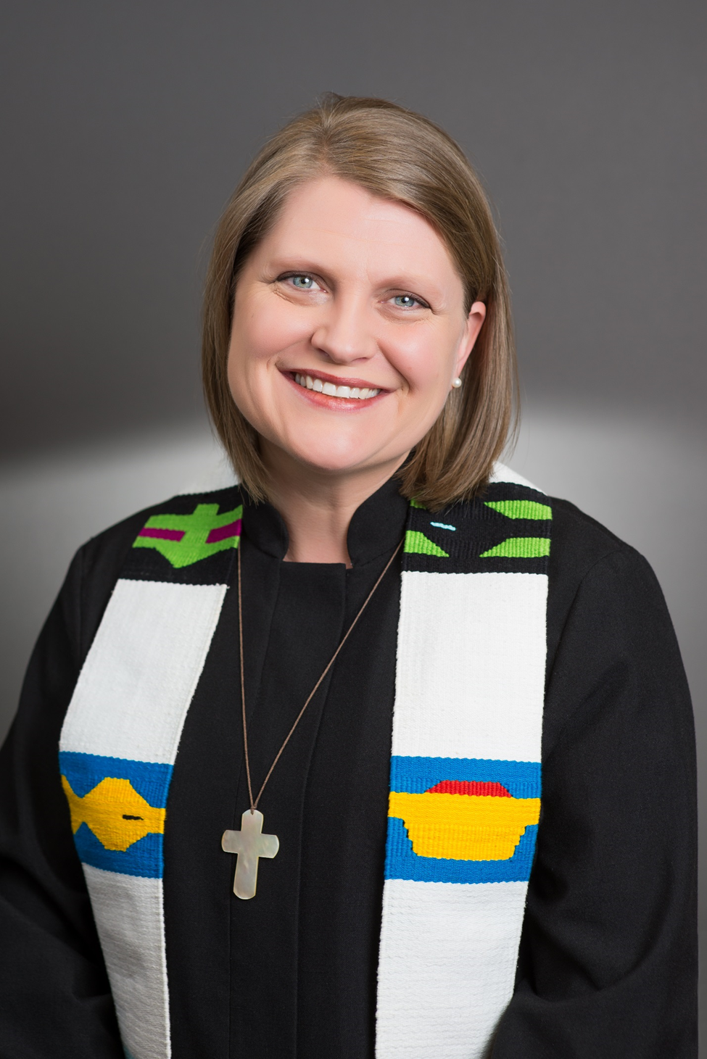
Dear Friends,
Thank you for sharing my joy of ministry this day. Thank you all especially for your support, encouragement and love. I would not be the woman I am and serving God in this way if not for your dedication to God’s work.

I am so blessed to be called to serve as your pastor in Kennewick. It feels like “home” to be back in Washington again. God has great plans for this church and this community. May we enjoy the journey together.
My new contact information is: Hanna Peterson Shearer, 6619 Aintree Dr., Pasco WA
(509) 316-8500 / (509) 582-9537 (office) / pastor.hanna@kfpc.org

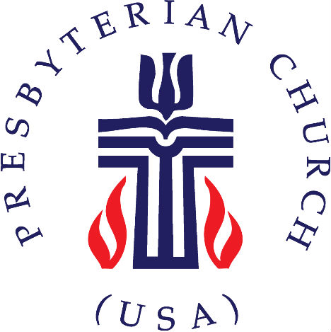

THE NORTHWEST COAST PRESBYTERY
Celebrates the Installation of
Rev. Hanna Peterson Shearer

April 30, 2017
3:00 PM – Garden Sanctuary
FIRST PRESBYTERIAN CHURCH
KENNEWICK, WA

